Practical - 3
Practical Title: Responsive UI Design using CSS Grid, Flexbox, and Bootstrap/Tailwind

Problem Definition: Design responsive layouts for Home, About, Registration, Dashboard, and Events pages using CSS Grid and Flexbox. Optional to use CSS framework such as Bootstrap or Tailwind. Ensure mobile-first responsiveness.

Theory

1. How does the layout adapt for mobile, tablet, and desktop screens?
Answer: The StudentHub layout uses responsive design. The content, cards, navigation, and sidebar adjust their size and position according to the screen size. It works properly on mobile, tablet, and desktop screens.

2. Which layout technique is used and why?
Answer: CSS Flexbox and Grid are mainly used. Flexbox helps align elements such as the navigation and buttons, while Grid is useful for arranging dashboard cards. They make the layout flexible and responsive.

3. Are typography, spacing, colors, and contrast readable?
Answer: Yes. Poppins and Bree Serif are used for clear typography. Proper spacing is maintained between sections and cards. The selected colors provide good contrast and make the text easy to read.

4. Is the framework used consistently without unnecessary inline CSS?
Answer: Yes. The project follows a consistent CSS design across different pages. Common styles are kept in the external CSS file, which reduces unnecessary inline CSS and makes the website easier to maintain.

Implementation
For the StudentHub Portal, responsive layouts were created for the Home, Registration, Dashboard, and Events pages using HTML and CSS.
- CSS Flexbox was used for the navbar, header, buttons, forms, sidebar, and aligning different elements.
- CSS Grid was used for dashboard cards, feature cards, and event cards.
- A mobile-first approach was followed so the website works properly on mobile, tablet, and desktop screens.
- Media queries were used to change the number of columns, spacing, and alignment according to screen size.
- A common CSS file was used to keep the same colors, fonts, buttons, cards, and overall design on all pages.
Code snippets:
CSS custom variables.
:root {
--primary: steelblue;
--background: #f5f5f5;
}
body {
background-color: var(--background);
}
h1 {
color: var(--primary);
}
Button :
button {
background-color: steelblue;
color: white;
padding: 10px 18px;
border: none;
border-radius: 6px;
}
button:hover {
background-color: darkblue;
cursor: pointer;
}
This helped make the Portal responsive, organized, and easy to use on different screen sizes.

Evidence of Work (Screenshots)
Figure 1.1 Index
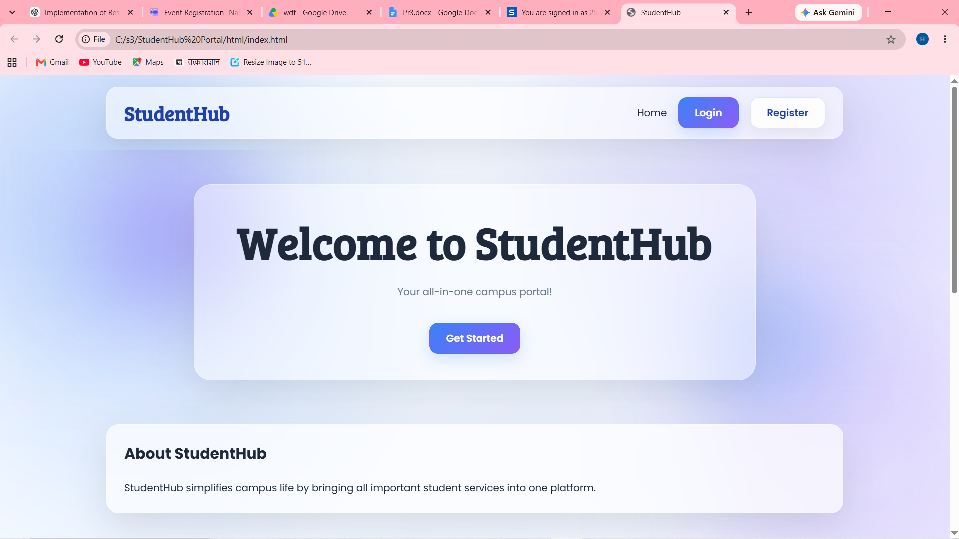

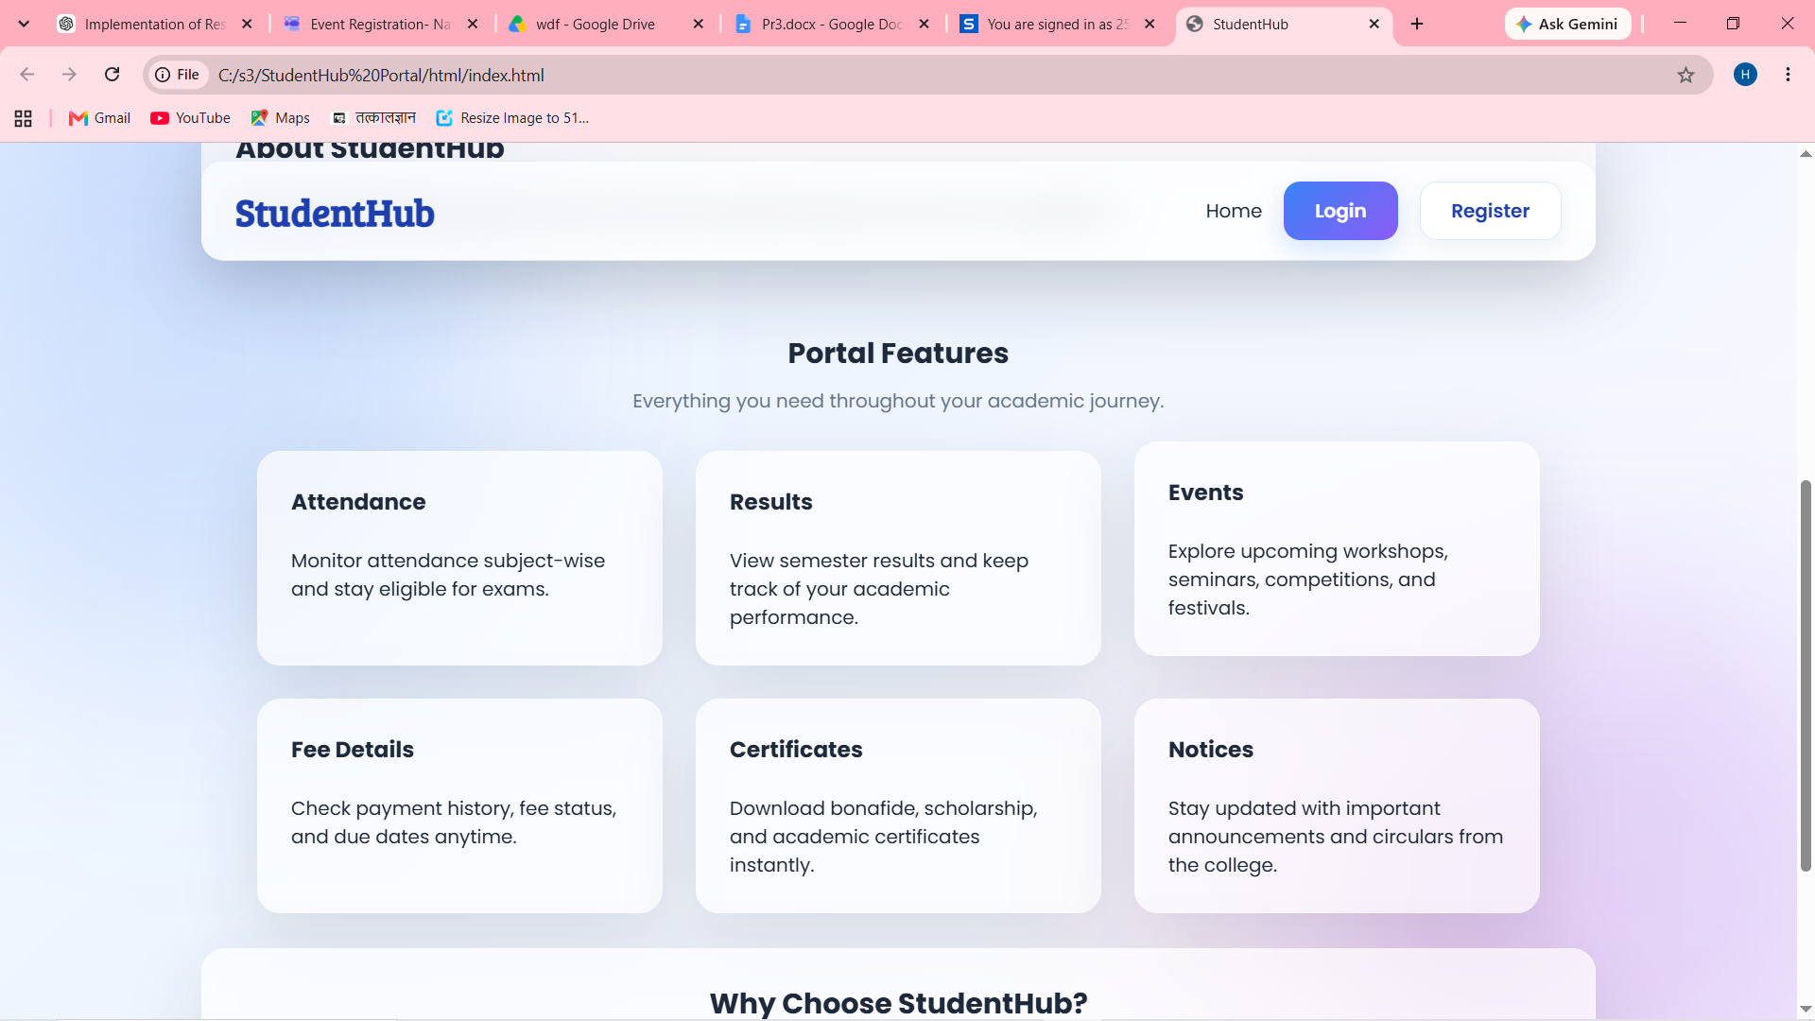
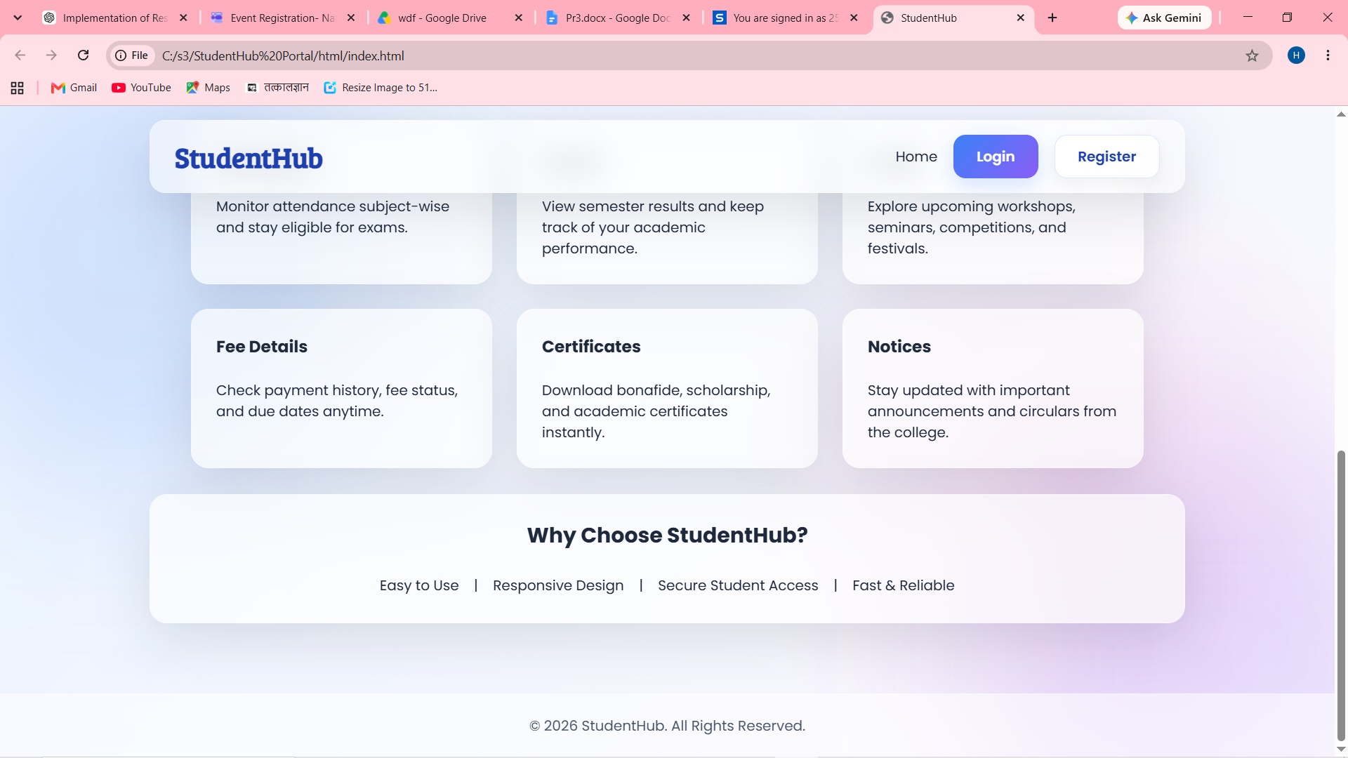
Description: This is home page when user opens website link
Figure 1.2 Login
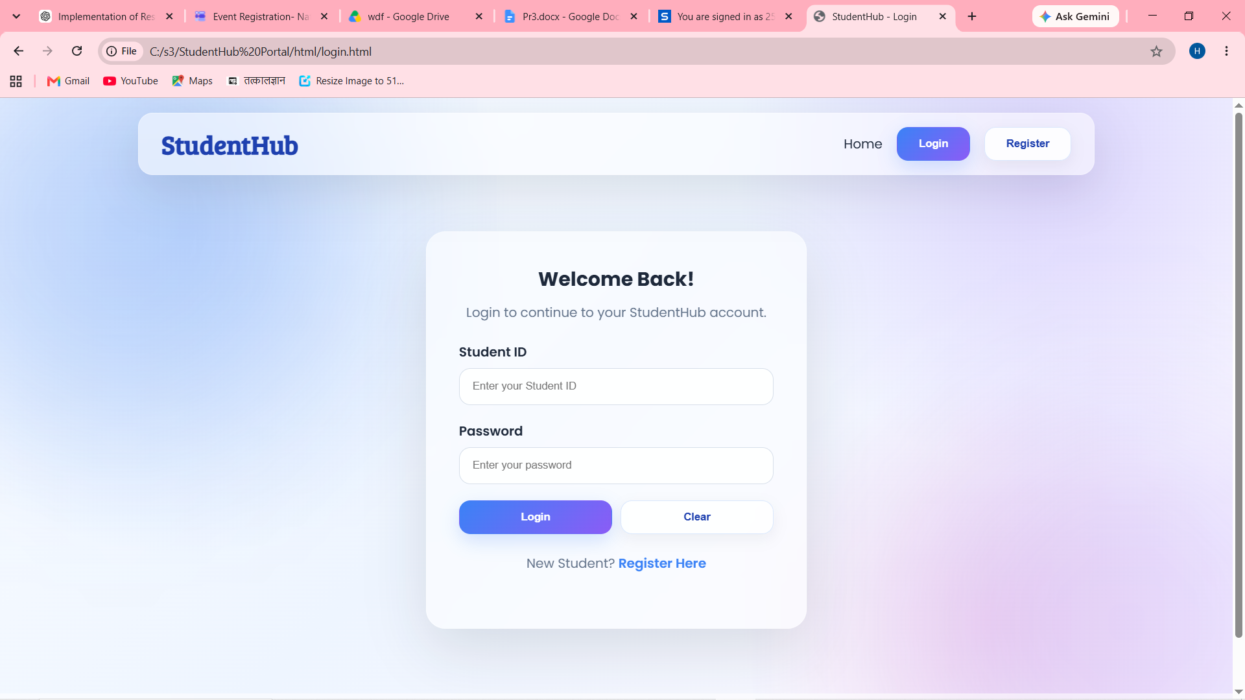
Description: This is login page for registered user

Figure 1.3 Register
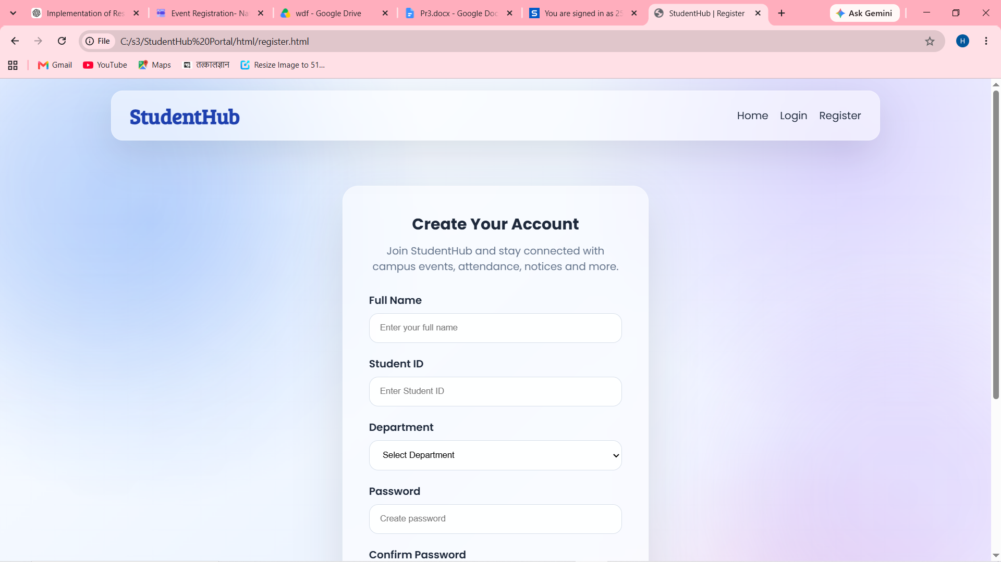
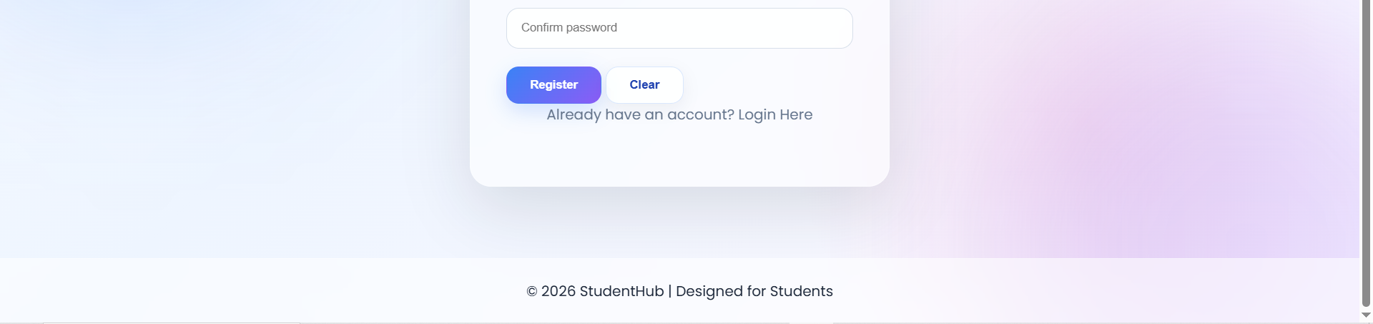
Description: This is register page for new users

Figure 1.4 Dashboard
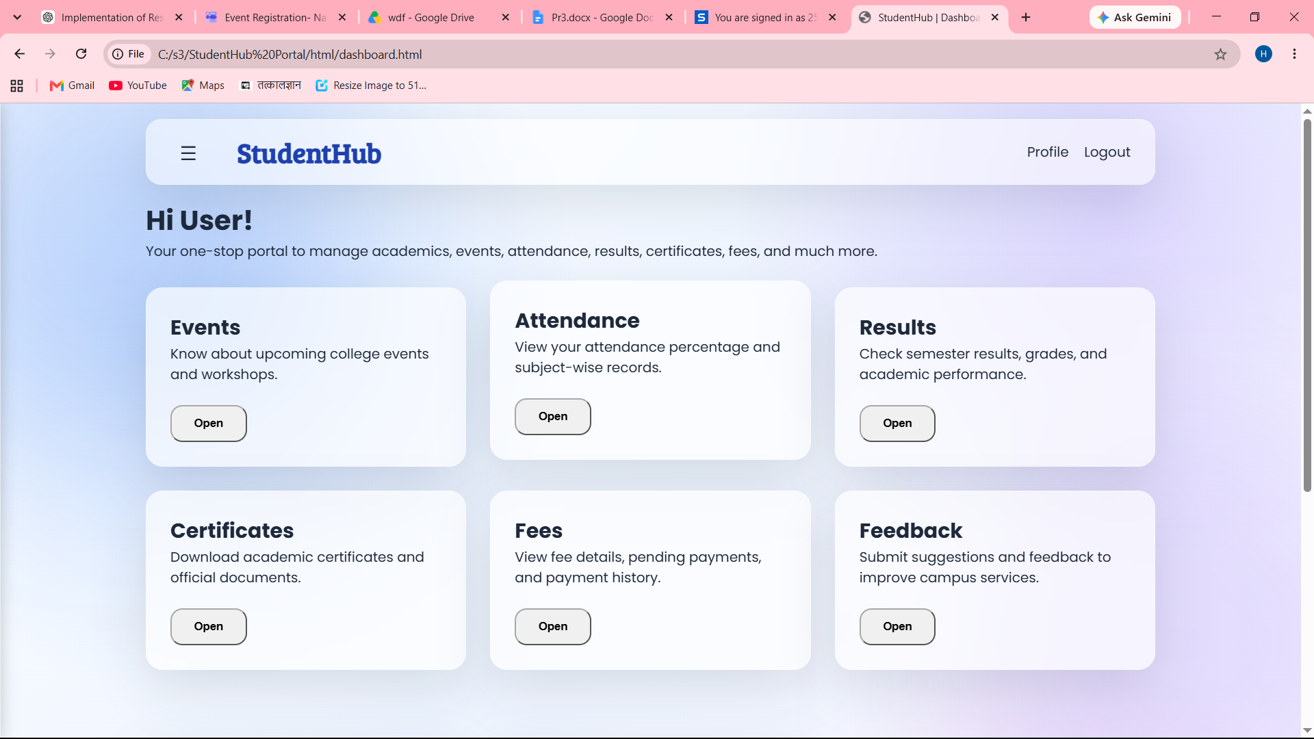
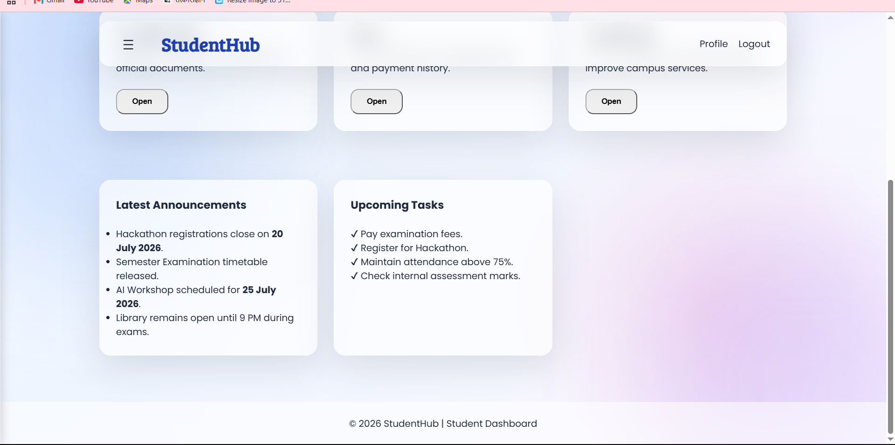
Description: This is a dashboard when a user will log in.
Figure 1.5 Event
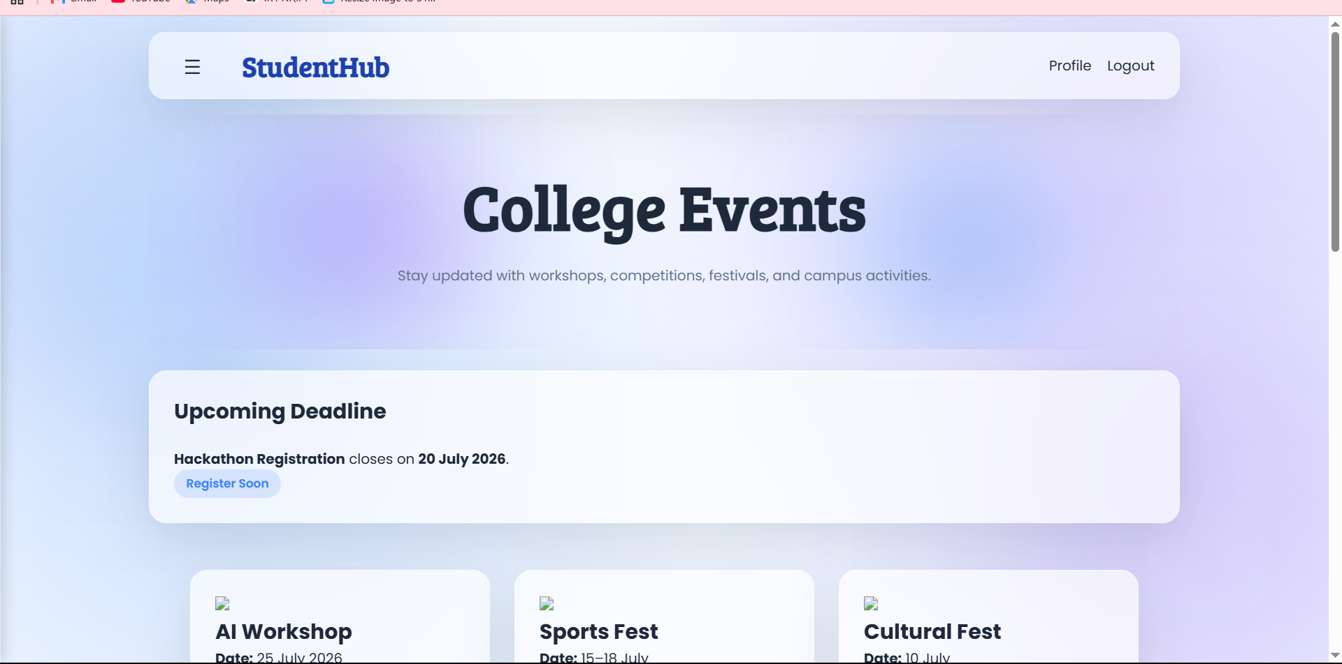
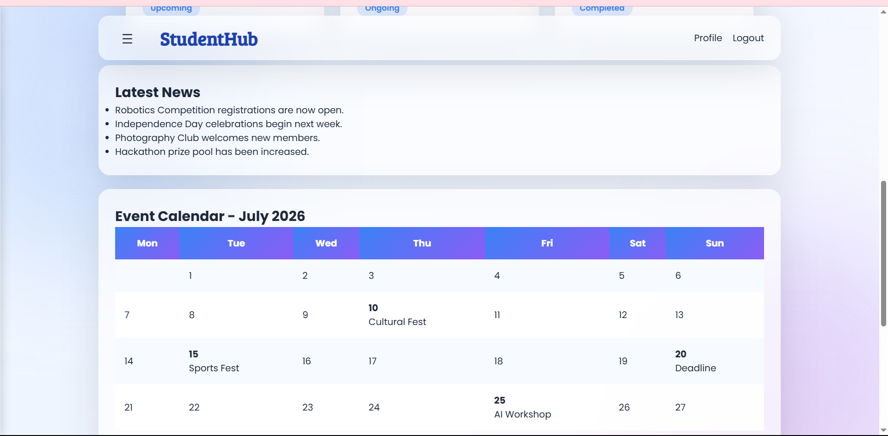
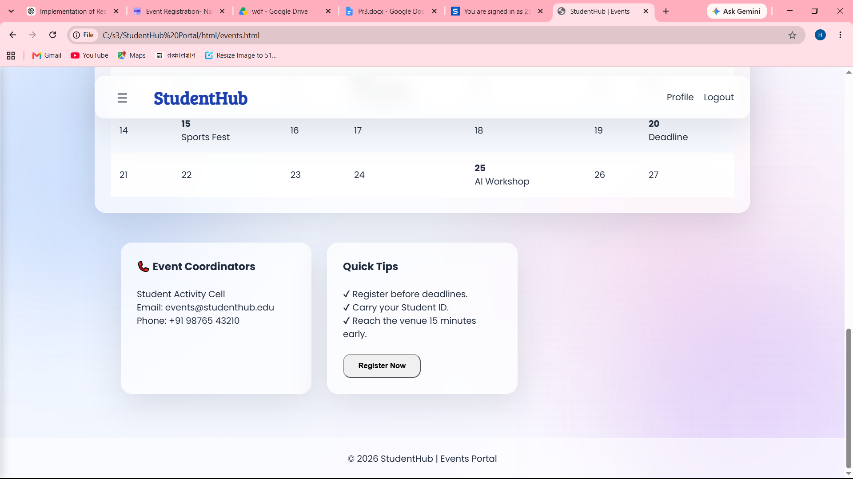
Description: Event page for latest events details

Figure 1.6 Attendance Page
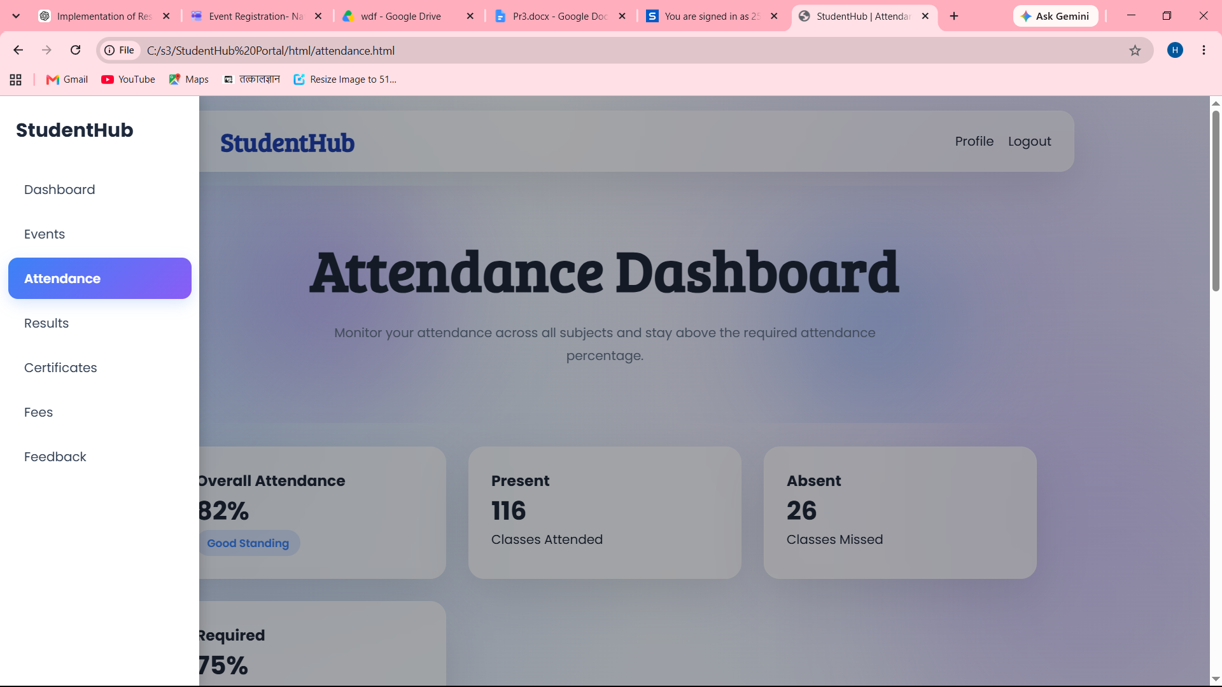

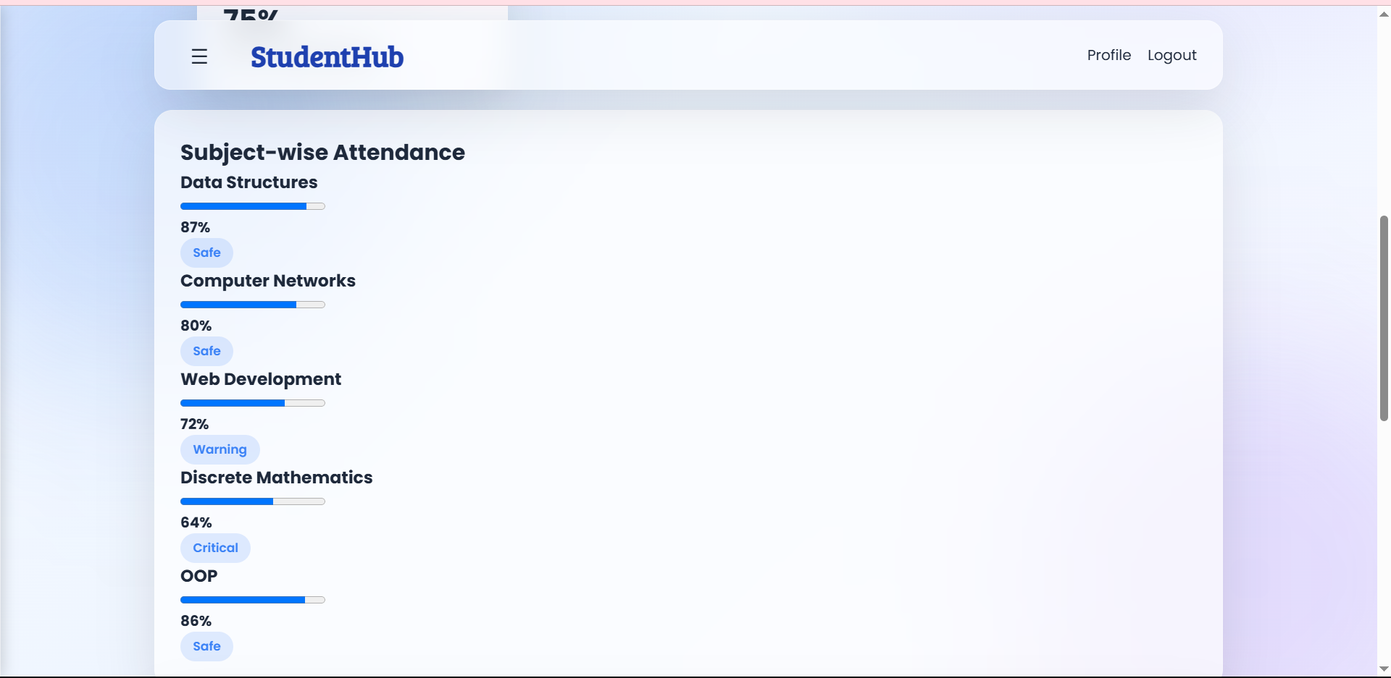
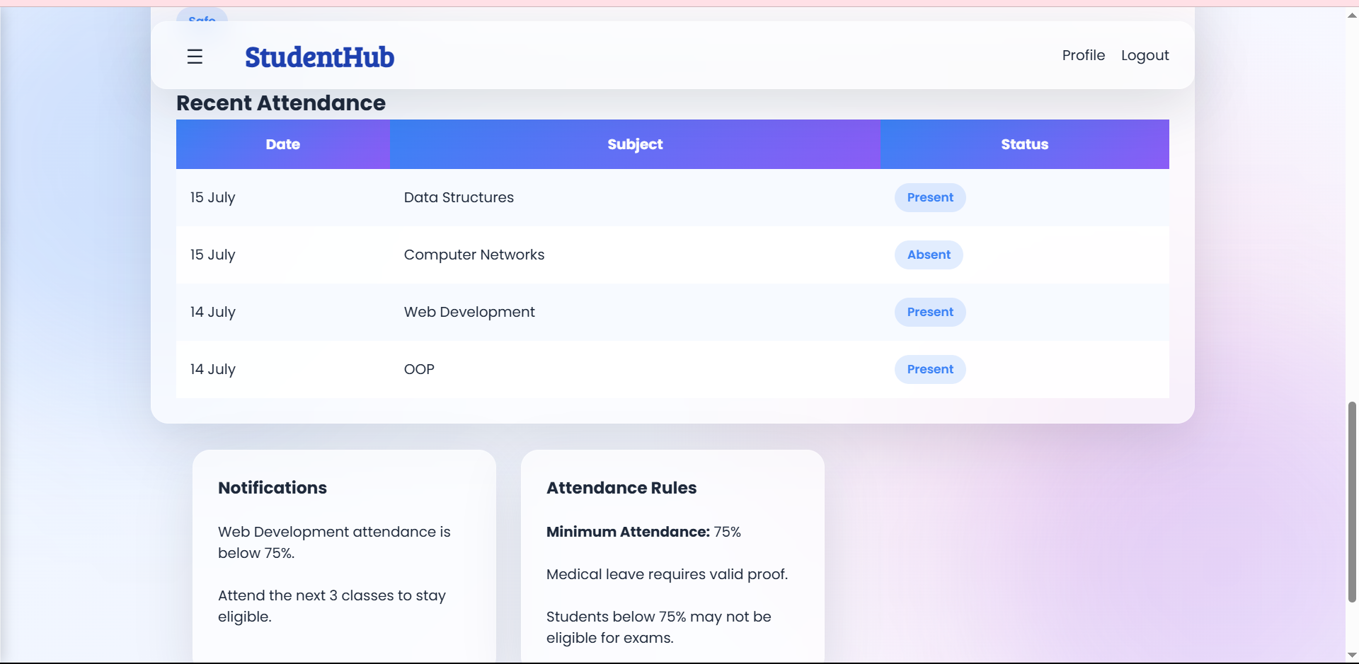
Description: This is attendance reports page for user

Figure 1.7 Results
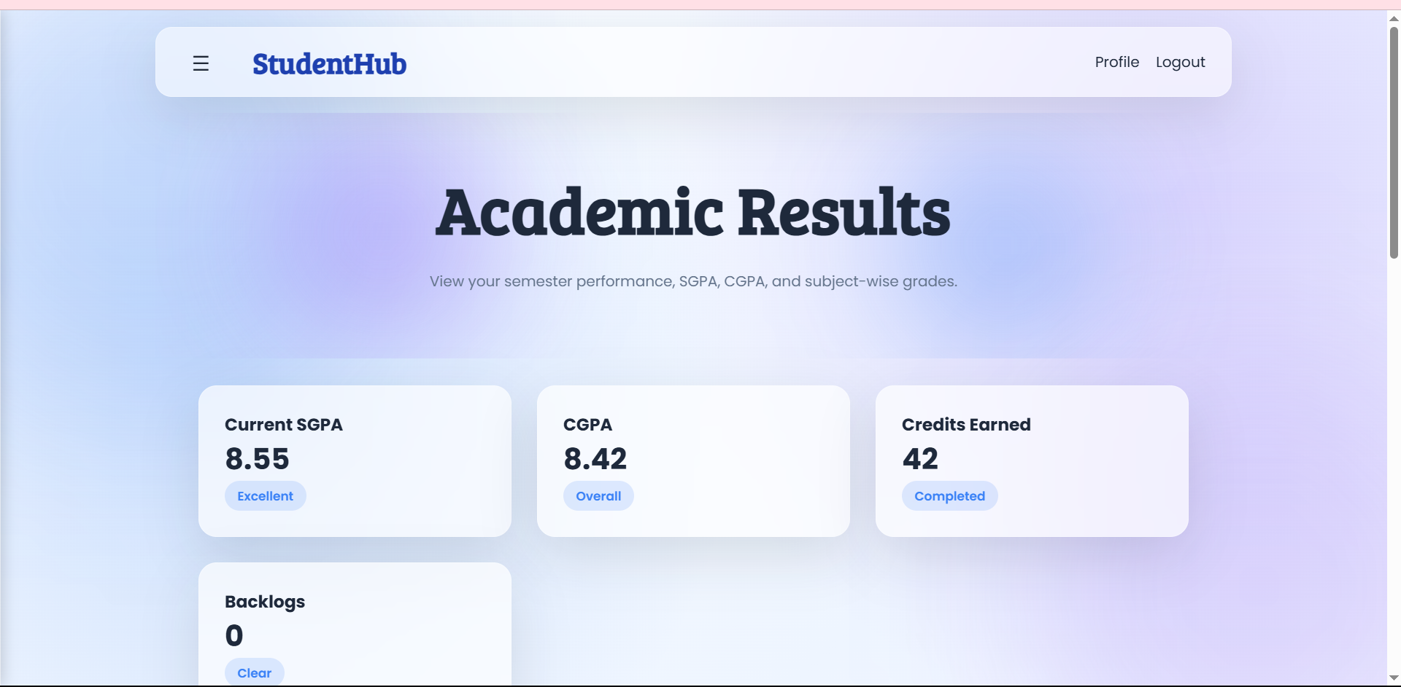
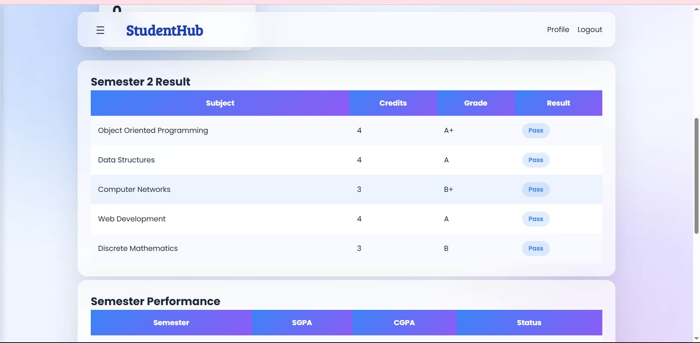
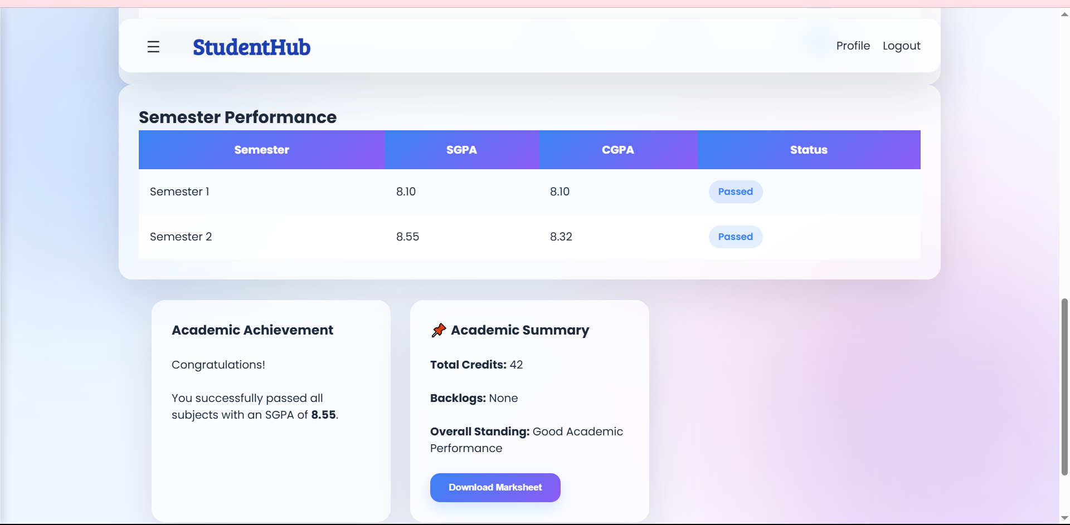
Description: This is result section for user

Figure 1.8 Certificate
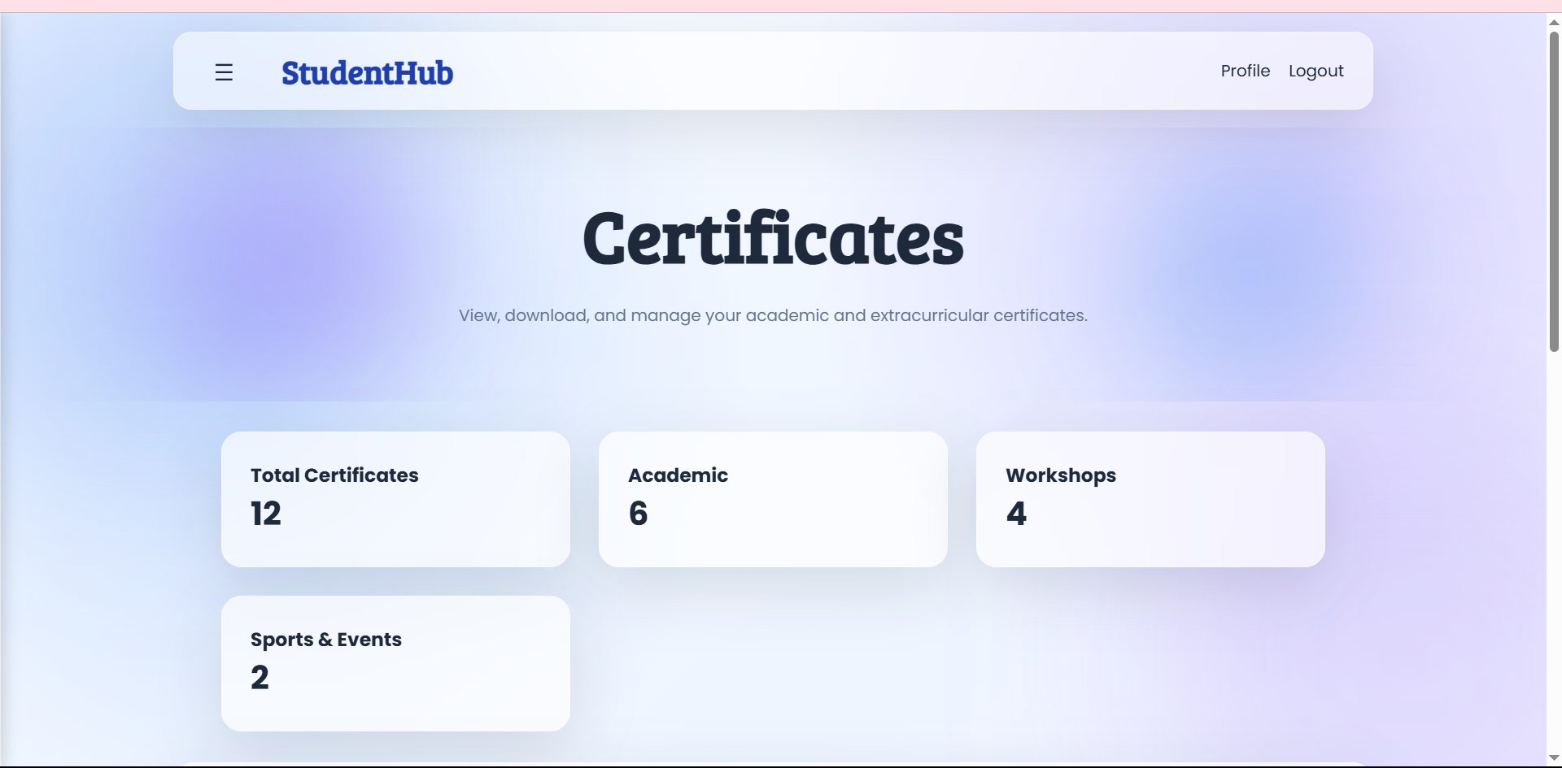
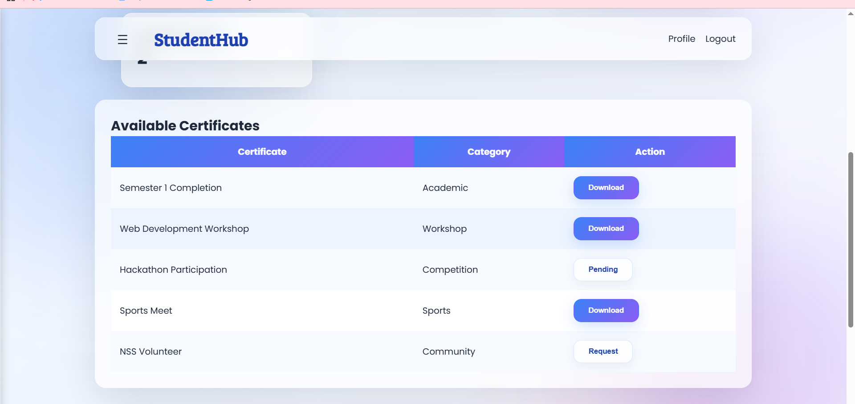
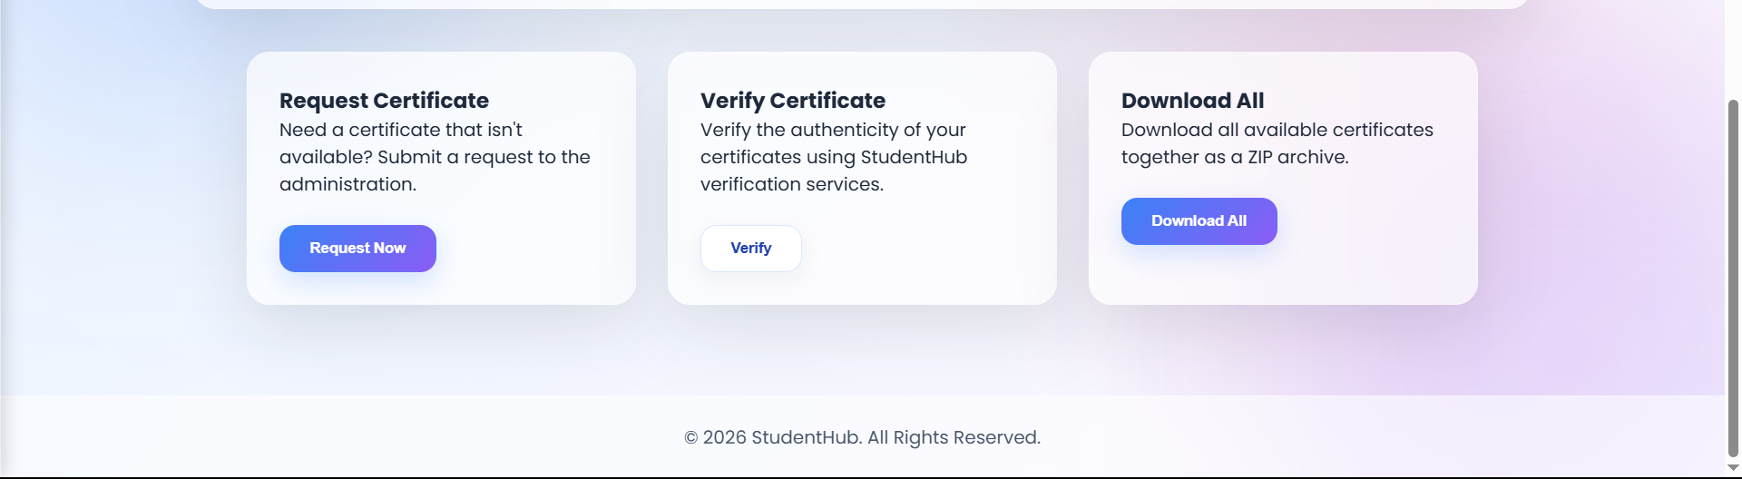
Description: This is certificate section for user
Figure 1.9 Fees
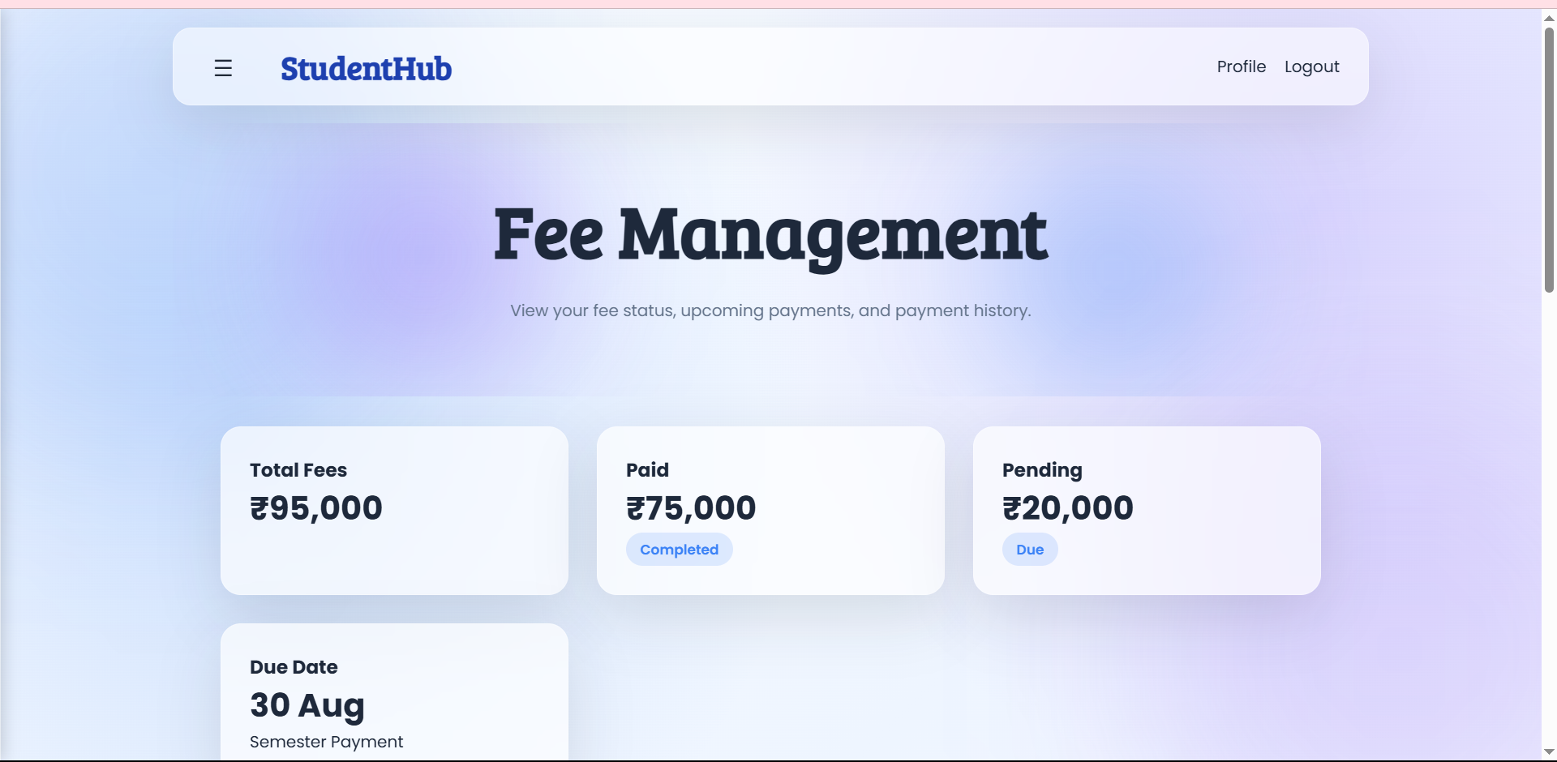
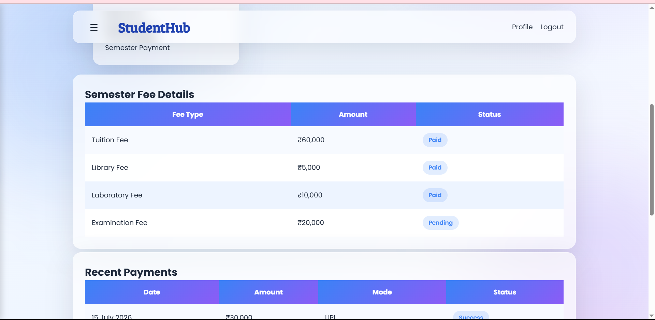

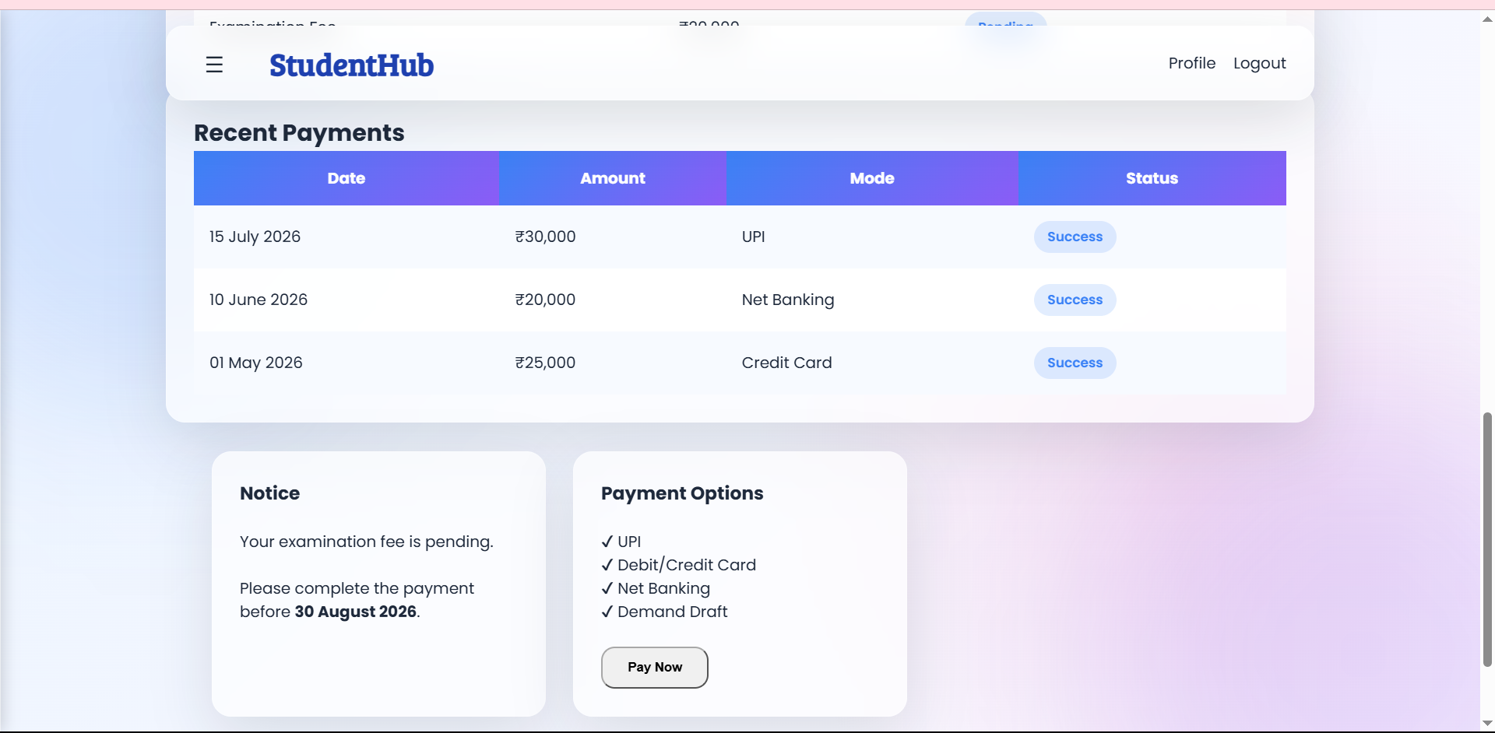
Description : This section gives info and direction on fees payment

Figure 1.10 Feedback
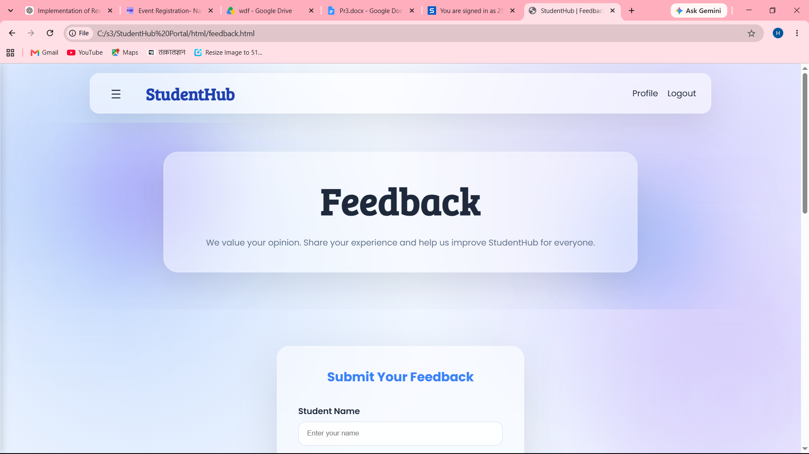

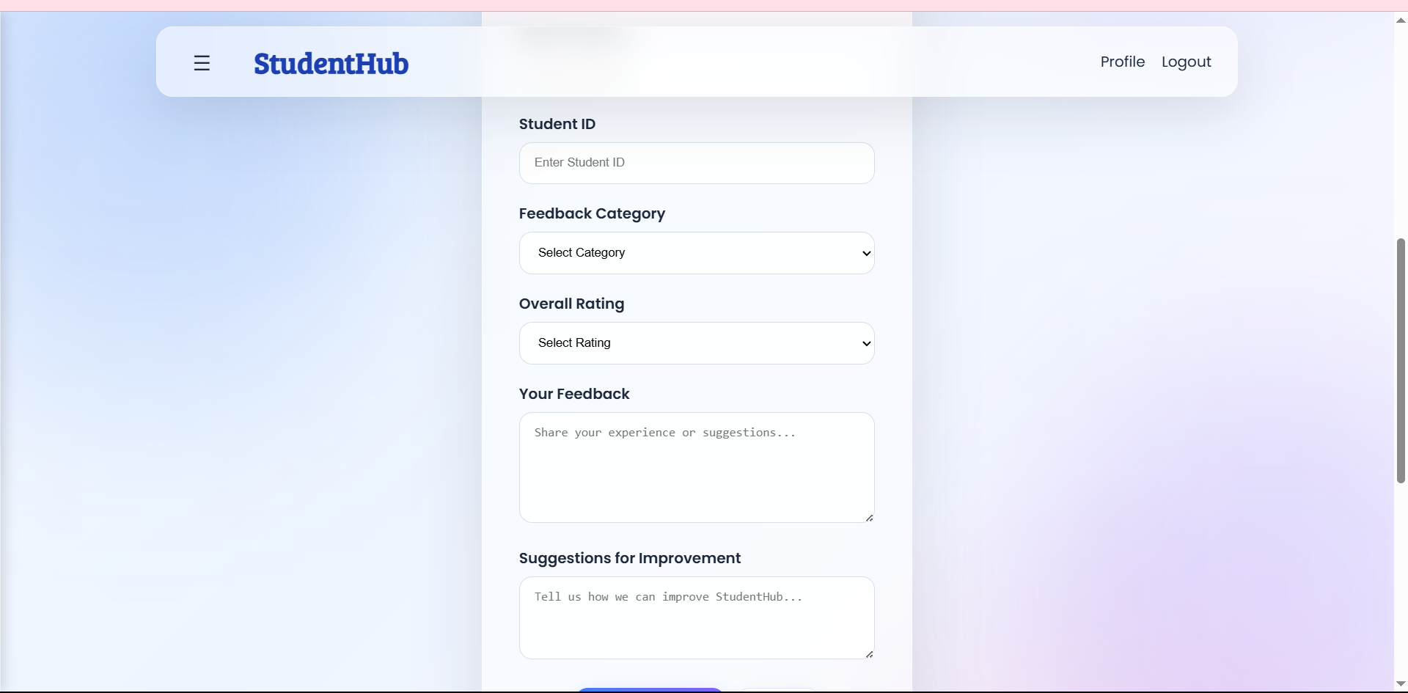
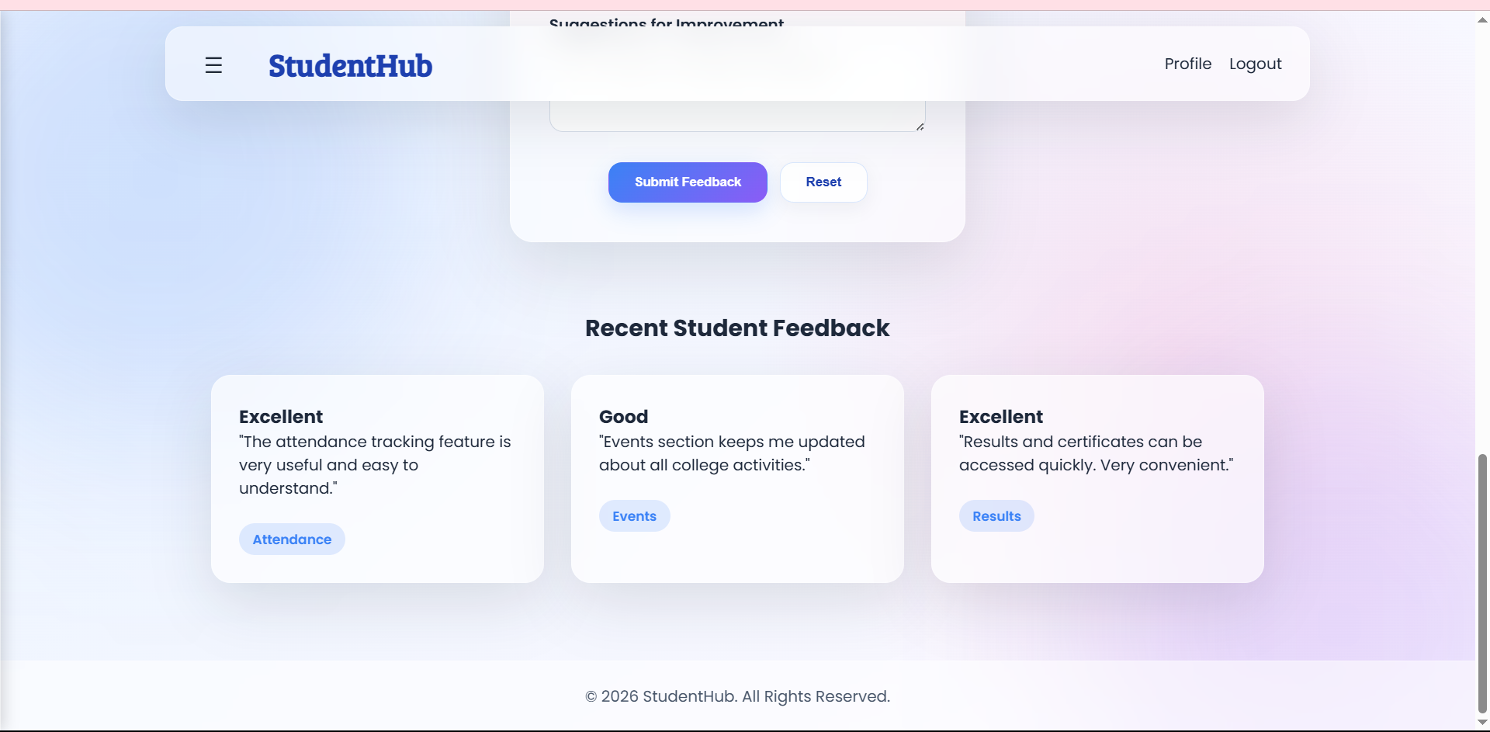
Description: This section helps in keeping up with users feedback on website

Figure 1.11 Profile
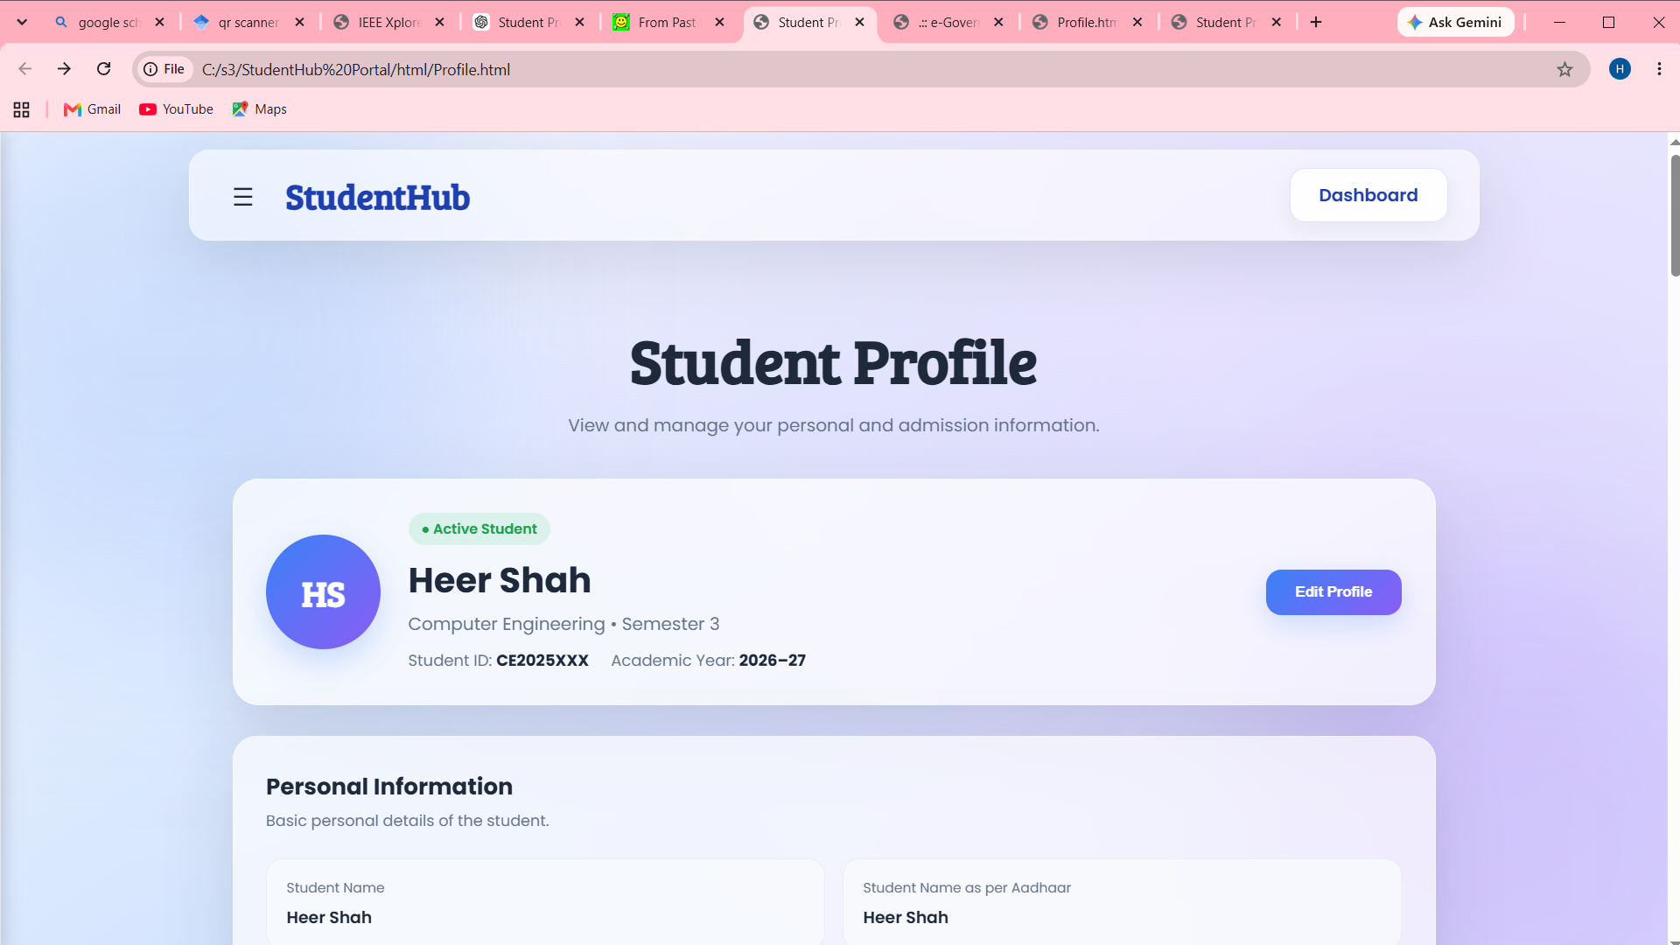

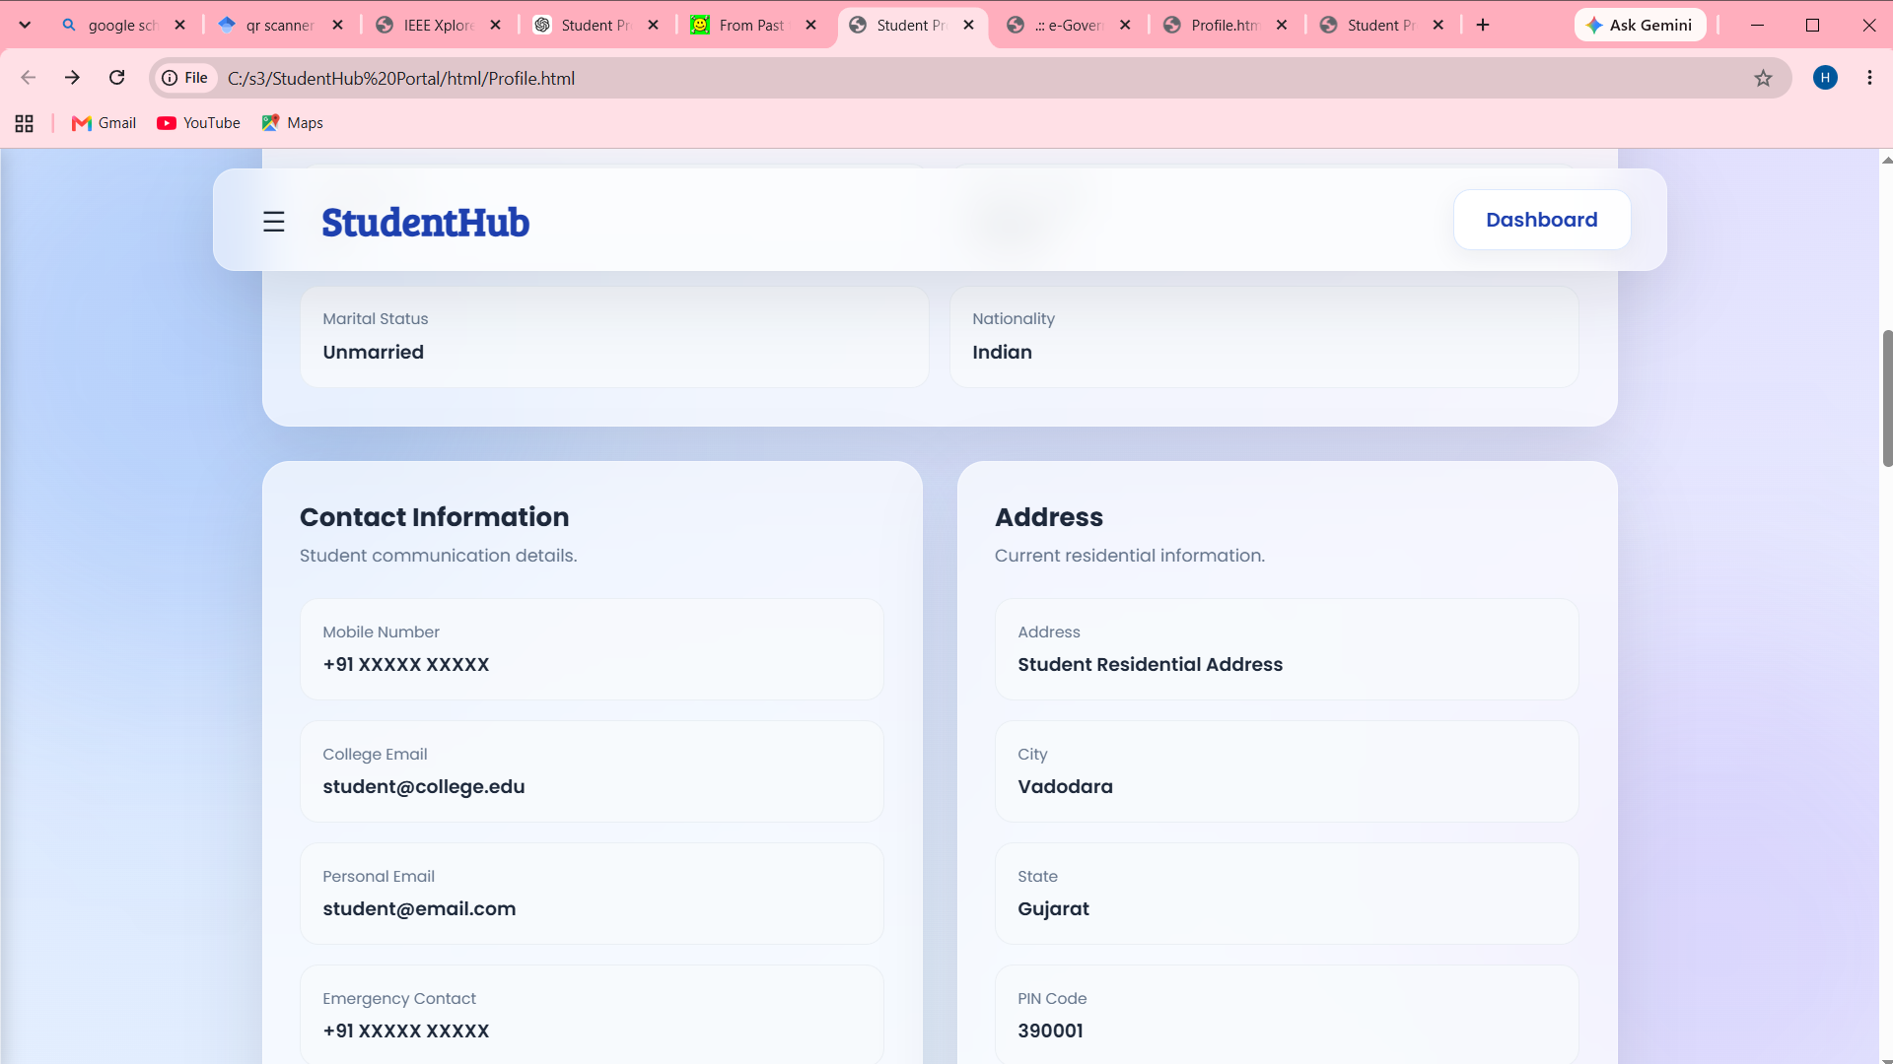

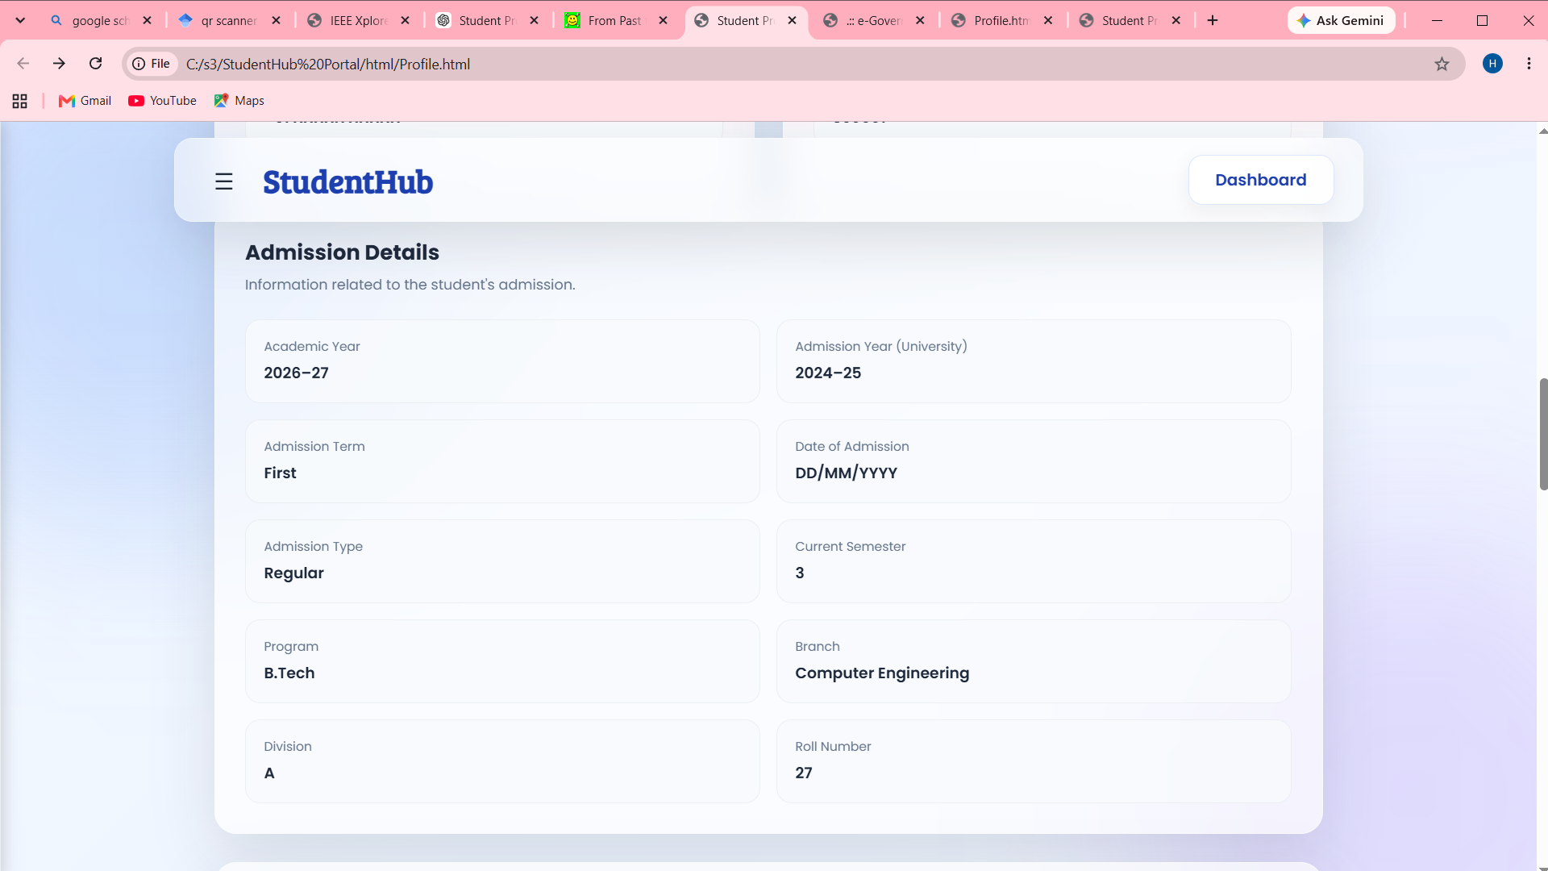

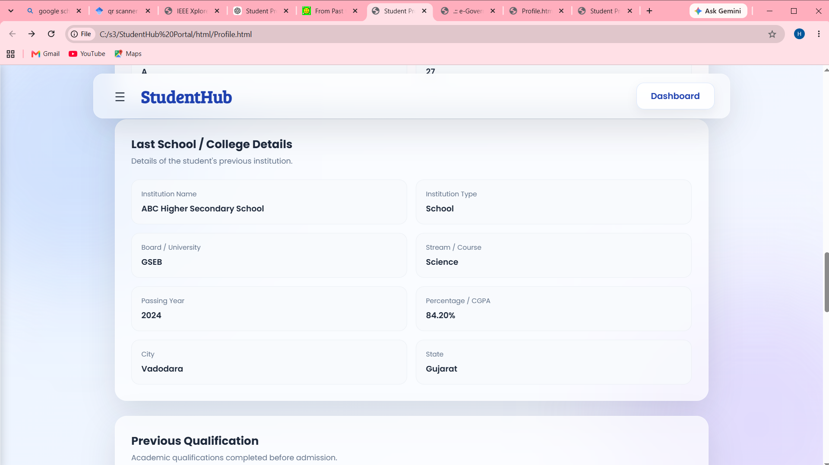

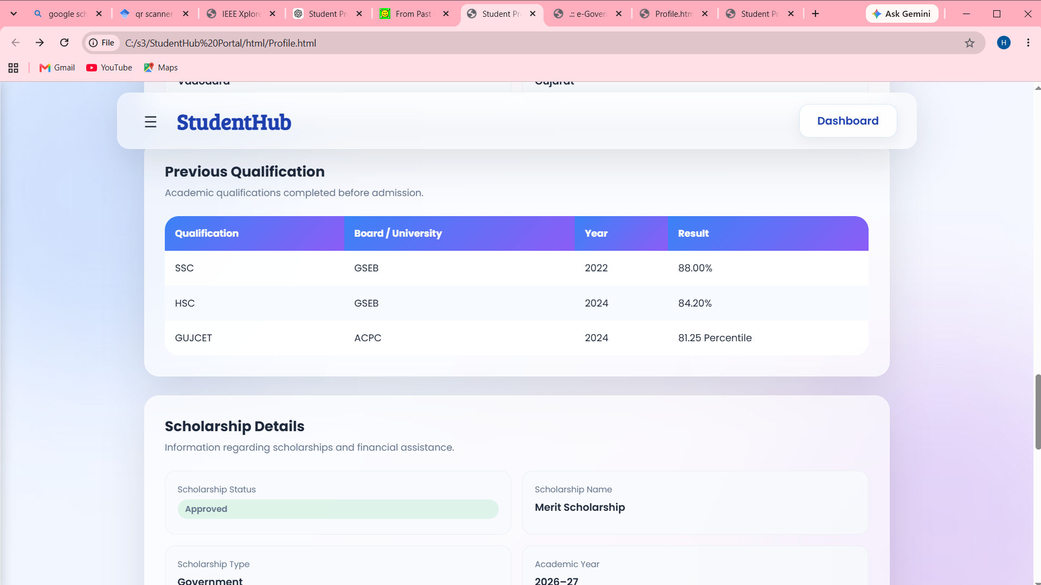

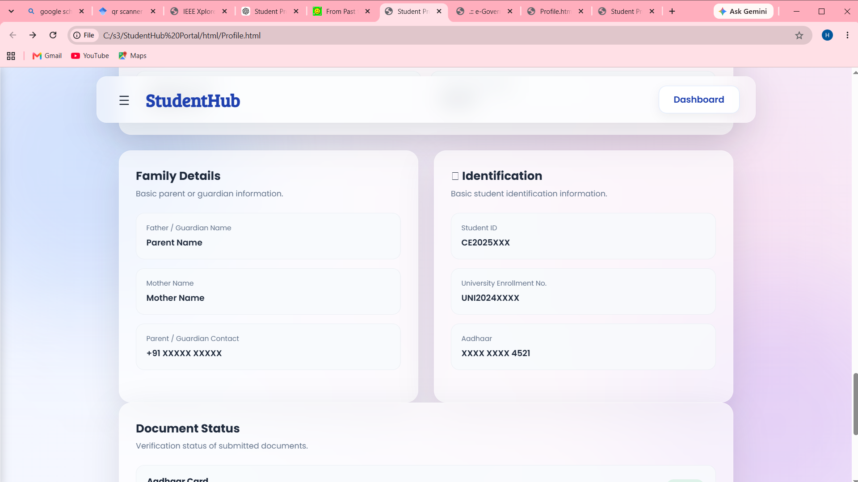
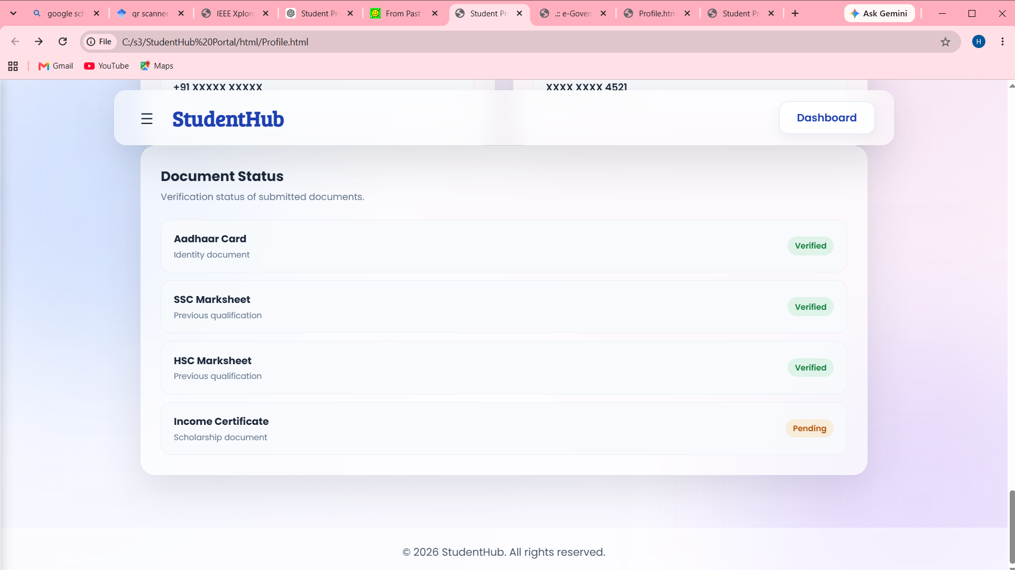
Description: This page is a profile page containing information about the user.

GitHub Repository Link:
https://github.com/heerce27/StudentHub-Portal.git

Challenges Faced:
I faced many challenges while designing this style.css like fixing button alignment and spacing on different pages, Preventing text and content from spreading too much horizontally, Managing card widths and alignment, as some cards were stretching across the page, Making the sidebar and menu button work properly without affecting the existing layout.
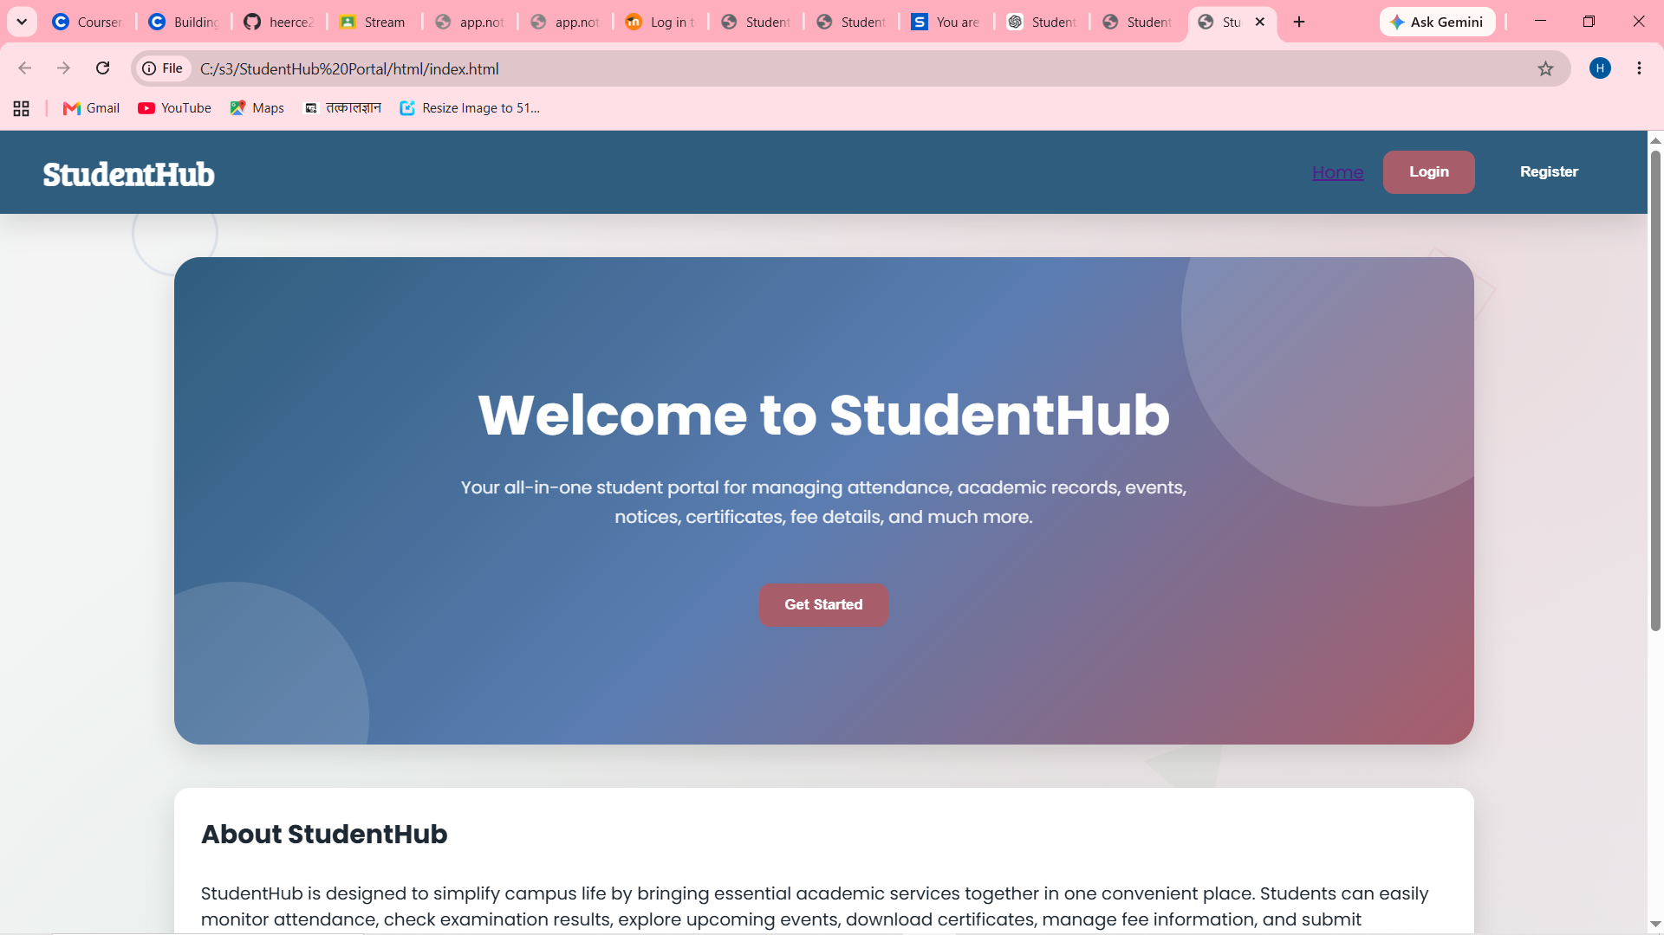
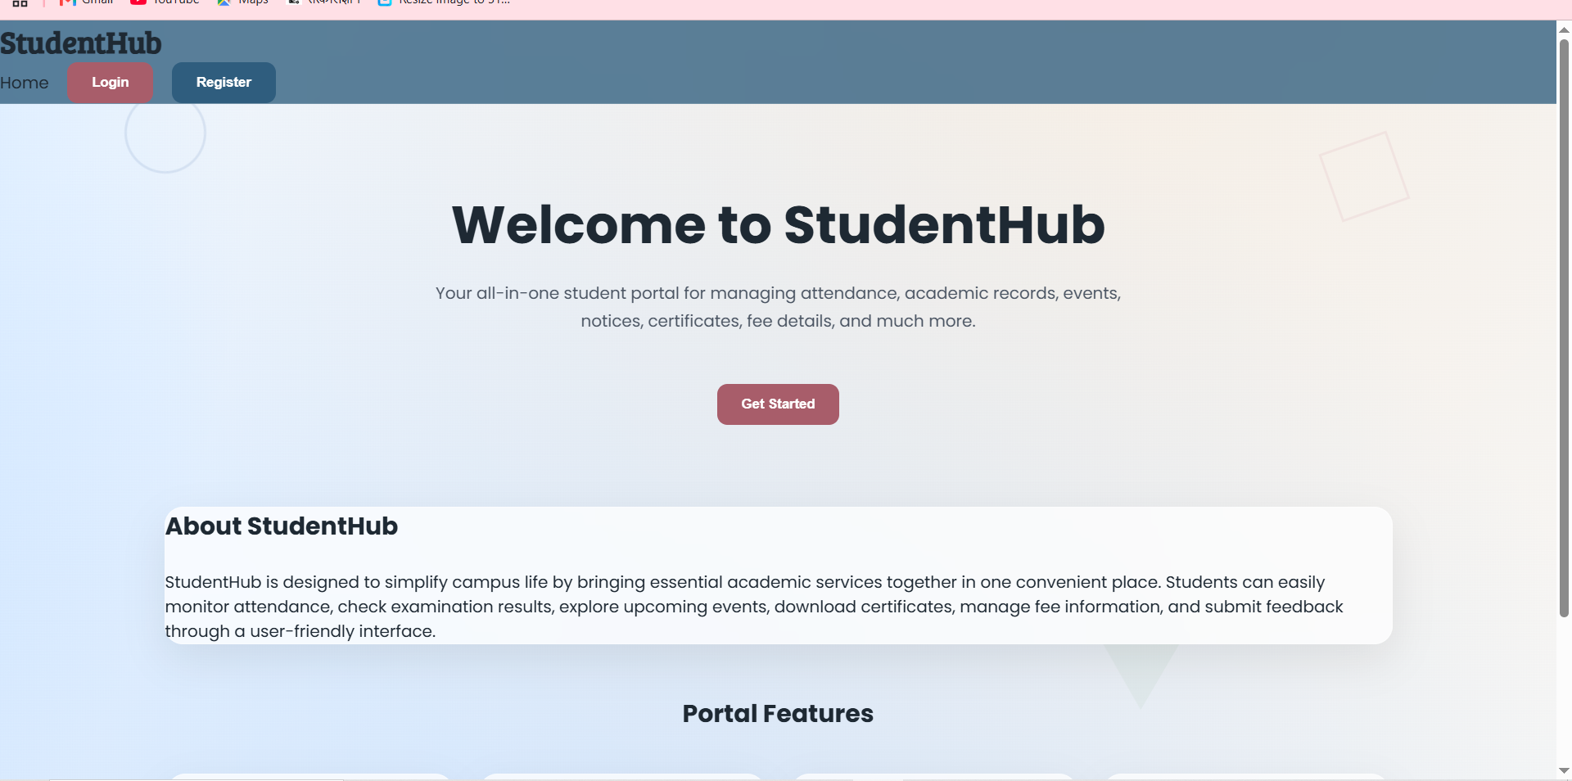
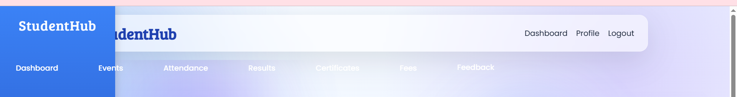
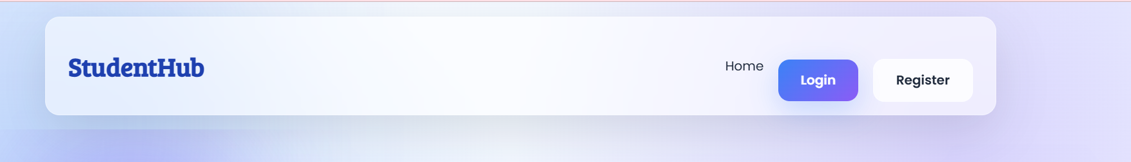

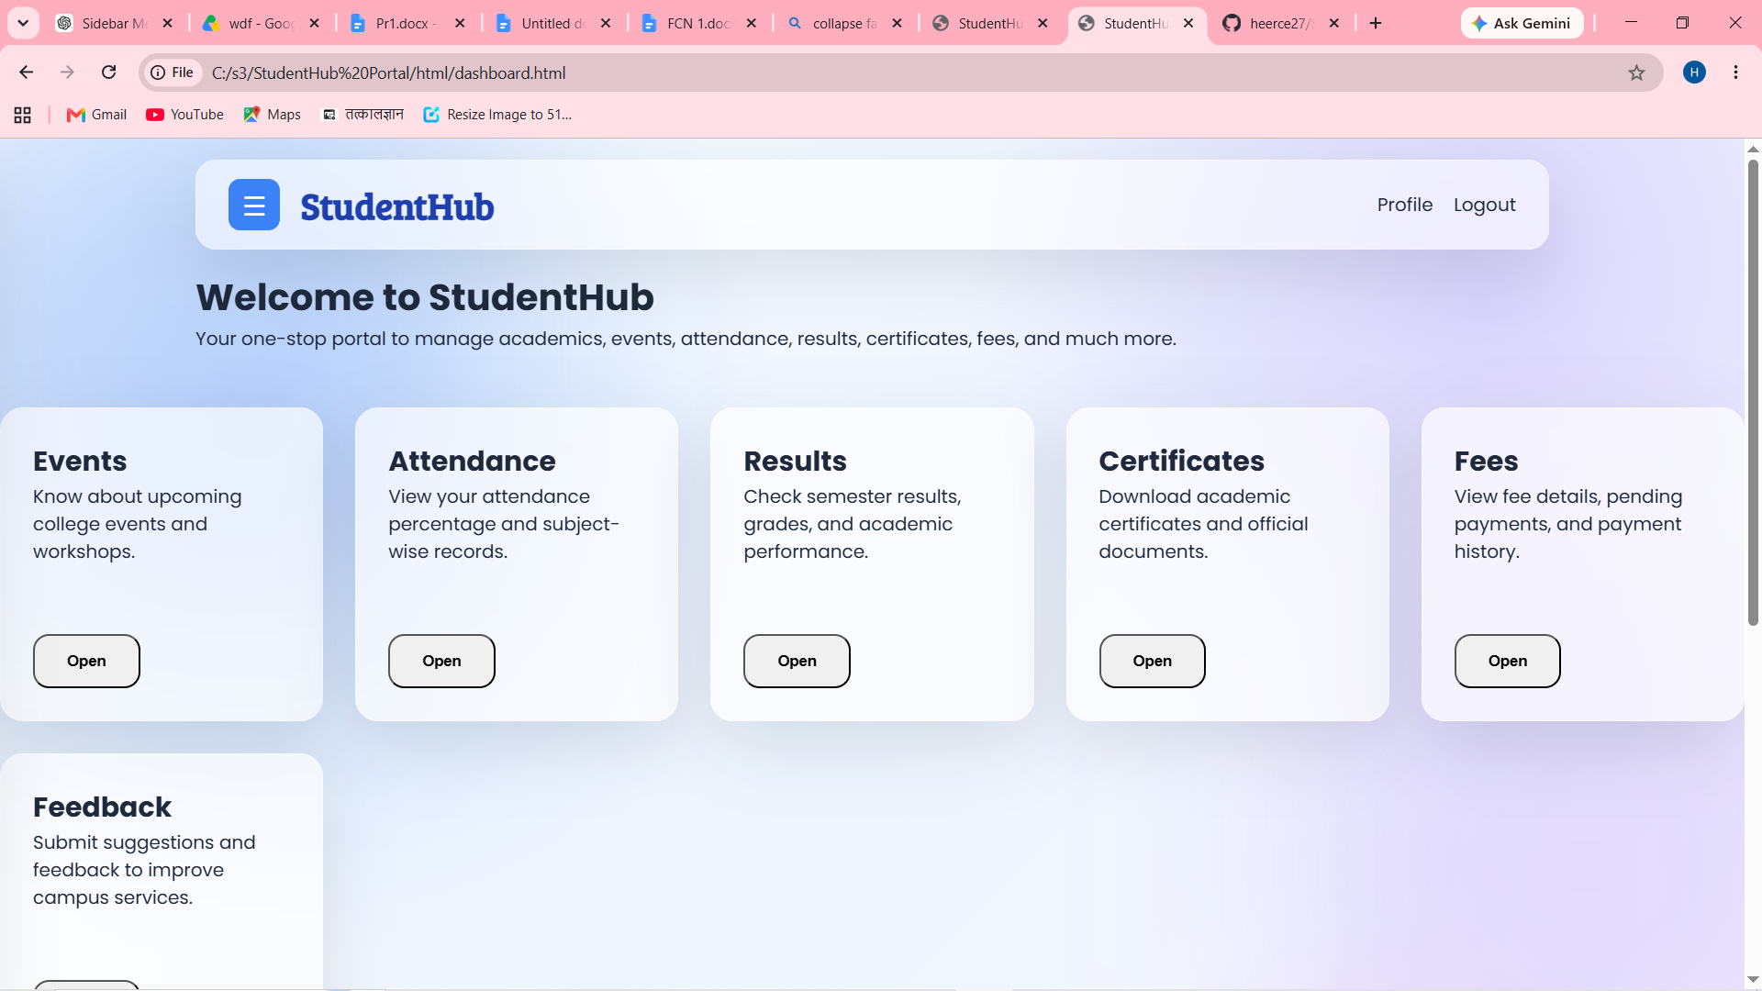

Learning Outcomes:
While creating this css i learned
- How to use CSS Flexbox and Grid for arranging website elements.
- How to create responsive layouts using media queries.
- How to choose and maintain a consistent colour, font, spacing, and button style.
- How to fix common layout problems like overlapping elements, stretched cards, and alignment issues.
- How to organize CSS so that the same styling can be reused across different pages.
- I also got better at debugging CSS and improving a design step by step instead of changing everything at once.

Faculty Remarks:

